MARKETING MATERIALS GUIDE

Make your clubs presence known! Promote your club, your clubs’ events and your members, be proud and let UC know who you are!
Marketing is so important to ensure that you are reaching your target audience and that everyone knows about you, here are some tips and tricks in how to increase your club presence.

- What should your club have?
- Logo and a slogan
- Membership Cards
- Badges + Merch
- Banners
- Table clothes (If you have not got one ask UCLifex)
- Marketing materials!!

- Marketing Materials
- Logo (use this on every document, email sent, advertisement and event)
- Brochures/Flyers (Great way to inform students about your club at market day)
- Promotional Items
- Signs and posters
- Social Media is your biggest friend!!!
- UCLifex (put a request in on uni one and we can help with promotion of events, promos ect)

- Designing the materials
- Design is important to ensure that your clubs’ advertisement is noticed around the university on social media.
- There are many design tools you can use to create graphics that stand out. Canva https://www.canva.com/ is a great tool that is free, and they have heaps of templates that can be used for banners, badges, cards, posters etc. Just click the marketing headline on the website.

- Promotion
- UCLifeX can help with promotion on events, fill out an event promotion form in UniOne
With details in where you want your event advertised ect.
- Ensure that all the sizing for your materials is correct sizing. For Poster’s it needs to be 42cm X 59.8cm (portrait). For the Tv Screens 1080px X 1920px (portrait). These can all be created in Canva using a free account.

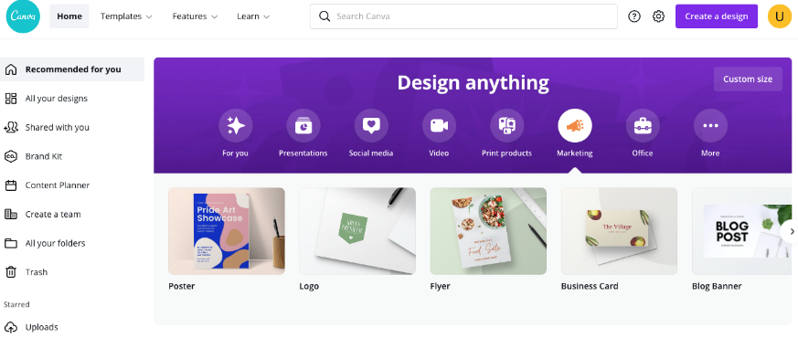
Once you have selected a template, you can add elements (clip art, doodles, shapes) or text via the side panel.
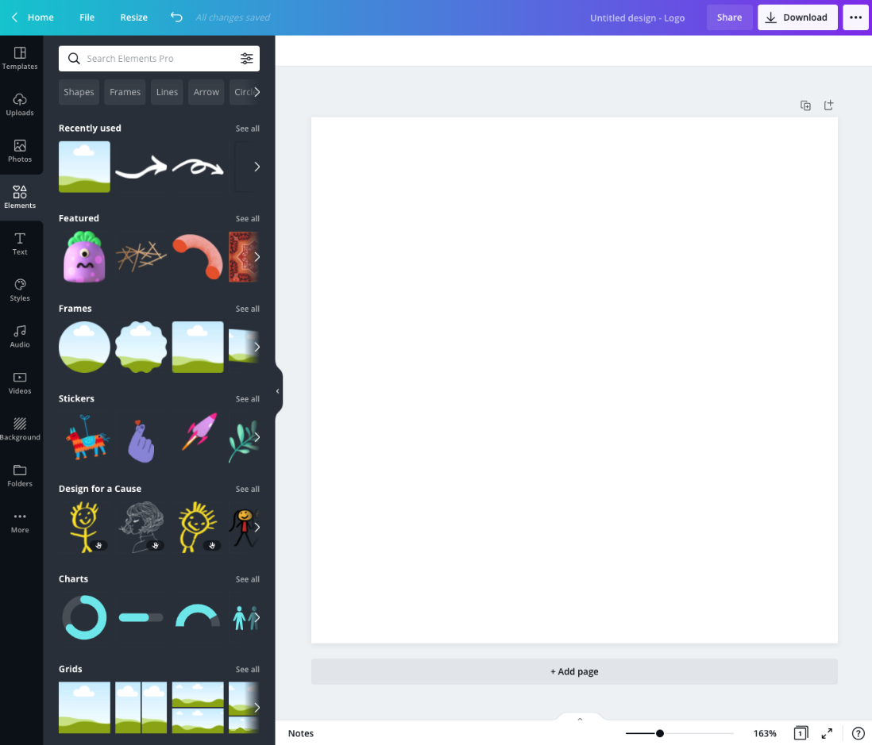

If you already have a logo, you can upload it onto the database using the option on the left panel and create your content accordingly.
It is essential to include UCLifeX branding on any events that are affiliated with UCX.
Here are two options for the UCLifeX logo. Copy and paste either of these PNG’s that are in the table.

Feel free to shoot an email to us at uclifeclubs@canberra.edu.au if you need any help with creating your promotional materials.

- Printing out the materials
Once you have completed your graphic, send us a copy at uclifeclubs@canberra.edu.au and we can print them out for you. In your email, make sure you specify:
- How many copies you need for membership cards/badges
- The size of the banner (A3 or A2) - we can arrange A-frames for you if required
- The date and time you plan to collect the printed materials from the UCX Office.
Alternatively, you could approach print suppliers such as Officeworks and CITSA Print.
Officeworks offers online services for printing business cards cards/events stationery, posters, flyers, brochures, and sheet labels via https://www.officeworks.com.au/print-copy/home .
You can either design your own graphics via their online portal or avail their graphic designing services for $49-$399.

CITSA Print offers similar services and can be ordered online by filling out the Public Job order form found on https://www.citsa.com.au/citsaprint/ and emailing it to citsaprint@cit.edu.au .

- Distributing marketing materials
After collecting your badges/banners/cards, you can distribute them at your club/society’s events. Make sure to book a stall at Market Day where you can hang up your banner and give out your badges (And some freebies!). This is where you will meet most of your club’s new potential members so ensure that you have your marketing materials ready.

